PE Equipment in Your Home

PE Equipment | Items at Home | Games- Tasks-Uses | Challenges/ Modifications
Paddle/ Racquet  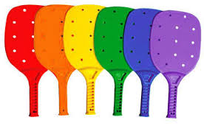 | Frying Pan  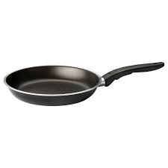 | Keep it up  Tennis Volley  Target Practice | C- Use ball  C- How many in a row?  C- Volley with partner  C- Keep score  C- Backhand / flips  M- Use balloon
Bowling Pin  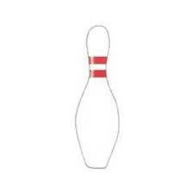 | Plastic Bottles or Cups  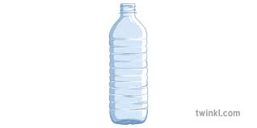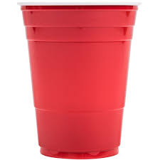 | Target Practice  Bowling  Cones | C- soccer/ hockey bowling  C- further distance  C- Keep score  C- Smaller ball / less pins  M- larger ball / more pins  M- Closer distance  M- Roll ball
Ball  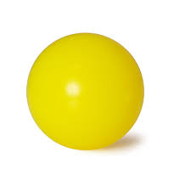 | Balled Up Socks  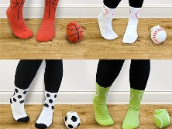  Balloon  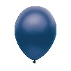 | Catch  Target Throw  Basketball shoot  Juggle  Broom hockey Ball  Keep it up | C- Smaller ball  C- Smaller Target  C- Catch with partner  M- Smaller ball  M- Smaller target  M- Self toss
Basketball Net  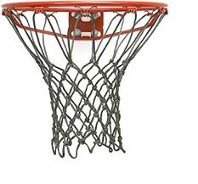 | Laundry Basket  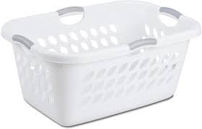 | Shooting  Distance shooting  Around the world  PIG  Disc Golf  Kan Jam | C- Farther Shot  C- How many in a row?  C- Higher up (on table/ couch)  M- Closer Shot  M- Lower to ground
Juggling Scarves  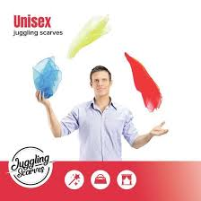 | Plastic Bags  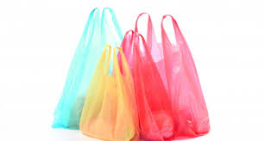 | Juggling  Throw and catch (K)  Catch ball in bag | C-Dish Towels  C- Juggling Checklist  M- Start with 2  M- Use 2-3 different colors
Volleyball or Tennis Net  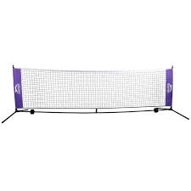 | Bed Sheet/ Yarn  (wrap around chairs)  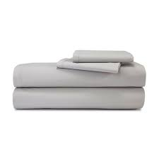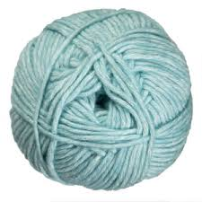  Tape/ Line | Volleyball – balloon or ball  Tennis – with partner  Tennis/ Vball- hit over net to target | C- Higher net  C- ball M- Balloon  M- Lower net  M- Use line or tape on ground to hit over
Frisbee  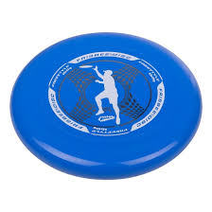 | Plastic Plate  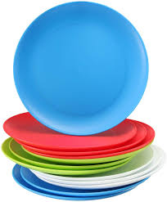 | Catch  Hit target  Disc Golf  Kan Jam | C- Farther throw  C- Hit a target  C- To a partner  M- Shorter throw
Hockey Stick  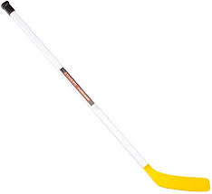 | Broom  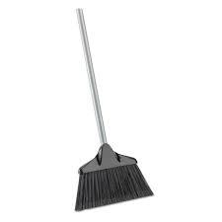 | Hit a target  Shuffle board  1 on 1  Shooting Practice | C- Further distance  C- Smaller target  C- Opponent  C- Add points  M- Closer/ Larger target  M-Open net
Hockey, Soccer Net  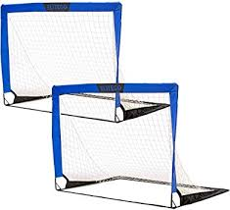 | Cone Markers (Anything)  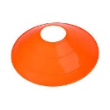  Tape on Wall  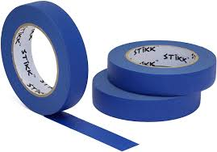 | Shooting skills  Blocking Skills  1 v 1 | C- Larger Net  M- Smaller Net  C/M- Number of shots
Parachute  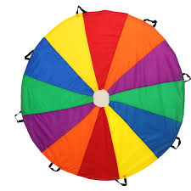 | Bed Sheet | Shaking  Popcorn – sock balls  Tent  Fort  Roll ball onto target | C- activity that require teamwork  M- Individual activities
Bean Bag  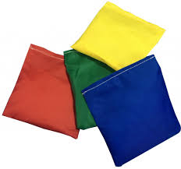 | Ziploc Bag Filled With:  Rice, beads, sand  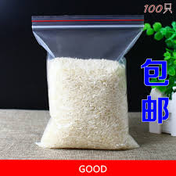  Wrap with tape or put in sock for extra security | Toss to target/ bucket  Cornhole  Shuffle board  Pancake flips in Pan | C- Increase distance  C- Keep score  C- How many in a row?  M- decrease distance  M- No score/ points
Golf / Hockey Ball  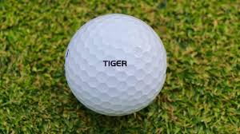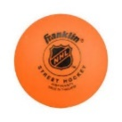 | Tinfoil Ball  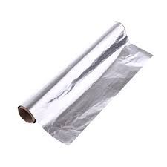 | Putt into cup  Create own course  Balance on pan  Stick Handle  Hockey Shot | C- Keep score  C- Increase distance  C- How long can you balance  M- Decrease distance  M- Bigger ball
Scoop  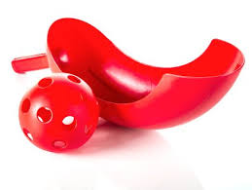 | Cut Milk Jug  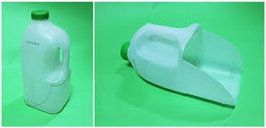 | Self throw and catch  Throw catch to partner  Scoop off ground | C- Increase distance  M- Decrease distance

